|  |
| --- |
| Short Report: Retail Developed Sims |

|  |
| --- |
| VAR Labs  Email: hnsheikh@conestogac.on.ca  Website: [VARLab Linkedin Page](https://www.linkedin.com/company/varlab-virtual-and-augmented-reality-lab/mycompany/) |

|  |  |
| --- | --- |
| Humza Sheikh, Project Assistant  Email: hnsheikh@conestogac.on.ca |  |



Table of Contents

Summary for report and Police Simulators: Patrol Officers2

Conclusion for Police Simulators: Patrol Officers3

Summary for Firefighter Simulator: The squad4

Conclusion for Firefighter Simulator: The squad5

|  |
| --- |
| Summary |

This short report will summarize the two retail developed simulators which are Police Simulator: Patrol Officers and Firefighters Simulators the Squad. Summarizing my findings and the problems that I have run into.

Police Simulators: Patrol Officers

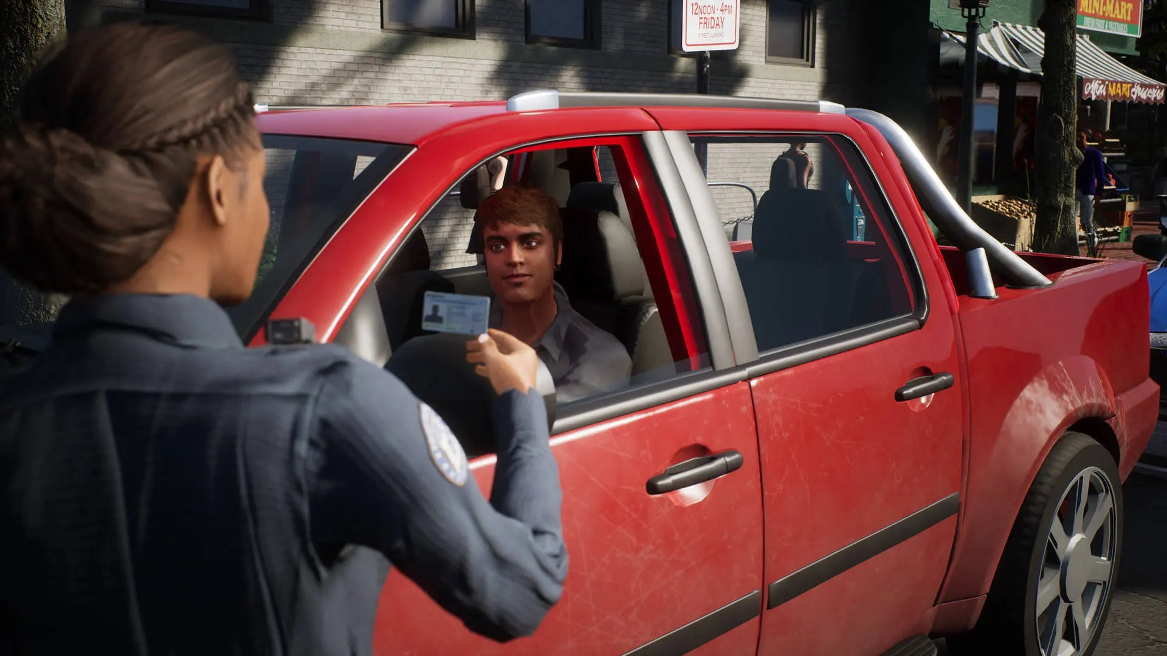

Join the Brighton police force and experience the day-to-day life of a police officer as you patrol the streets, going from giving tickets to stopping drug deals. This game has a dynamic traffic system that organically creates traffic flow and car accidents. The game offers simulation and casual modes.

Conclusion: Police Simulator Patrol Officers is a decent title with great gameplay mechanics that our team can leverage, such as checking the ID system, brunching options, and integrating into CIS (Crime Investigate Scene) sim or a new sim for the police department.

Conclusion

The ID mechanic allows the user to check if the suspect has a valid ID, insurance, or driver's license and if they have any priors. This helps the user to determine if the suspect is dangerous, especially in CIS simulator, where you are investigating the aftermath of the break-in of the diner and are required to check the ID for all the witnesses, which is required by law. This adds a level of accuracy and realism . This is an excellent feature to incorporate in CIS.

The branch options mechanic allows users to select different options depending on the situation which another great mechanic to incorporate.

Police simulator patrol officers have a lot of great gameplay mechanics that we can incorporate and is a great companion alongside CIS. The only problem that I run into is slow framerates and glitches.

Firefighting Simulator-The squad:

# Summary

Experiences what it means to be firefighter to face incredible odds in Firefighting Simulator – The squad. Team up with three of your friends or go solo to tackle missions across 40 diverse deployment locations stopping fires and rescuing civilians in a realistic simulator.

Conclusion: Firefighting simulator- The squad is a great title that portrays being a firefighter and the intensity of the job. Our search and research (SAR) simulator can leverage great mechanics, like how fires spread and grow, how victims are placed in different parts of the house, how to utilize the firetruck tools and how to set up the hose.

The fire mechanic in this game is more realistic than the SAR simulator. The fire in the SAR simulator would still be in place and not grow, which is inaccurate, whereas, in the game, the fire would spread and grow and even cause structure damage if the fire is not put out quickly. This mechanic would significantly improve the SAR simulator in accuracy and immersion.

Another mechanic that can be utilized is the firetruck ladder and hose, as well as how to set up the hose, which can expand the firetruck use in SAR simulator if incorporated.

Firefighting simulator: The squad has a lot of great gameplay mechanics that we can incorporate and is a great companion alongside SAR. The only problems that I run into are slow framerates, glitches, fire taking a long time to go out, and teammates not doing their jobs sometimes.